Set up a PIN for new token
NOTE: THIS DOCUMENT IS ONLY TO SET UP PIN FOR NEW TOKEN OR IF PIN OF AN EXISTING TOKEN IS RESET BY SECURITY ADMINISTRATOR.
- Click https://remote.mizuhocbus.com/vpn/index.html
- To set your PIN the first time or after PIN reset by your Security Administrator.
- User name: Enter your Mizuho network windows id; xx####
- SecurID PIN + Token: You should ONLY enter the token code that appears in the RSA SecurID app.
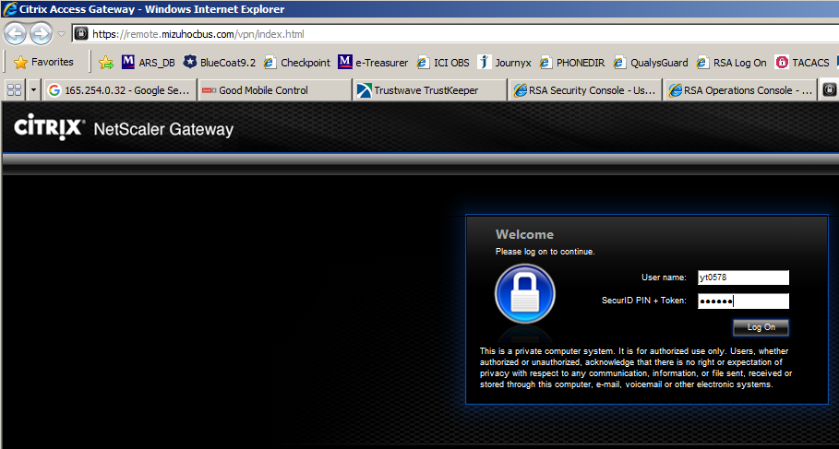
- You will then be prompted to enter a NEW PIN from 6 to 8 alphanumeric characters as shown below. You will be then be asked to re-enter to confirm your new PIN.
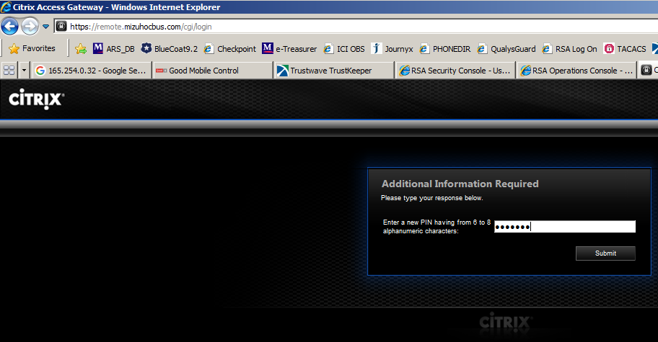
Re-enter your PIN to confirm 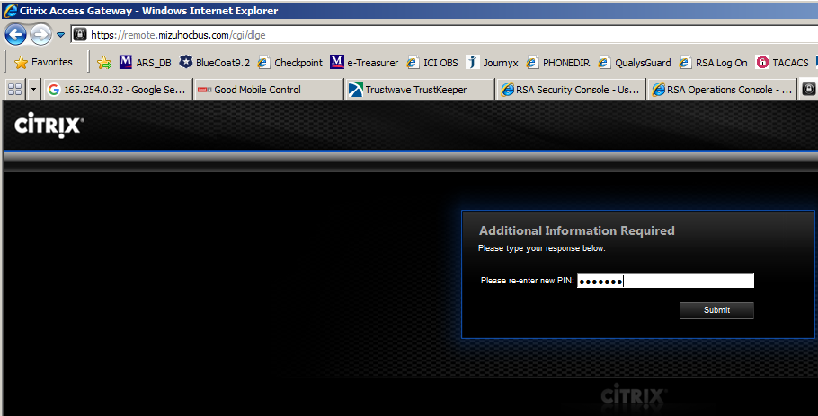
- You will next to prompted to enter your PASSCODE, which is the PIN you created + token code
Wait for the next token code to appear then
- Enter your PASSCODE (PIN + token code) For eg. If your PIN is qazx123 and token code 56739273 then your passcode is qazx12356739273
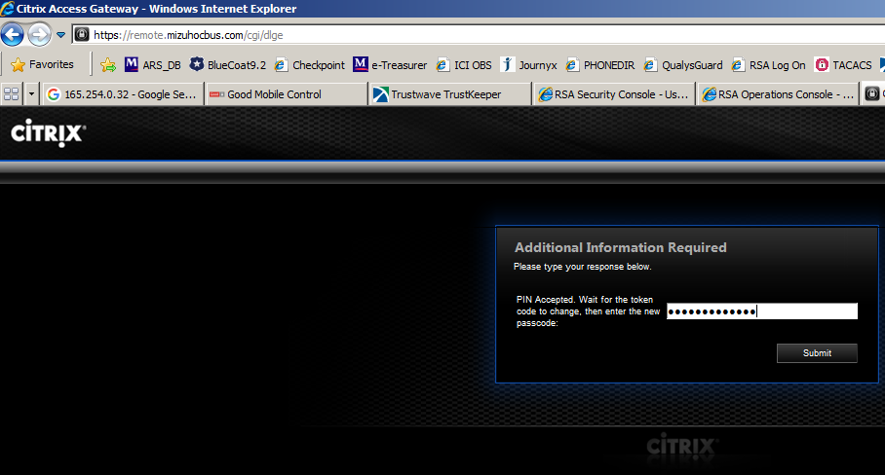
Please contact the helpdesk at x9400 if you are unable to login or need assistance.

